Dragonfly Balloons
http://www.dragonflyballoons.com/index.html
814-786-8094 or 724-982-8429 ● dragonflyballoons@yahoo.com

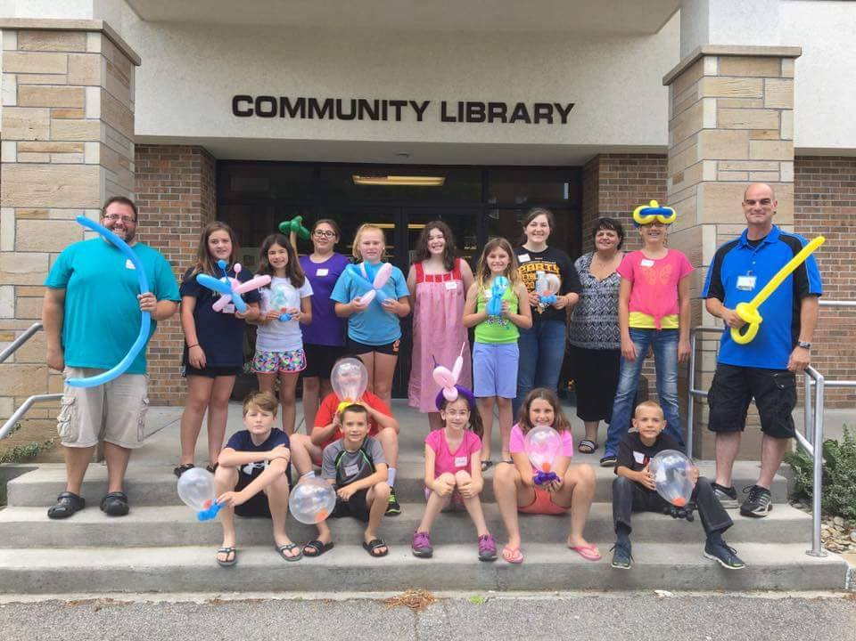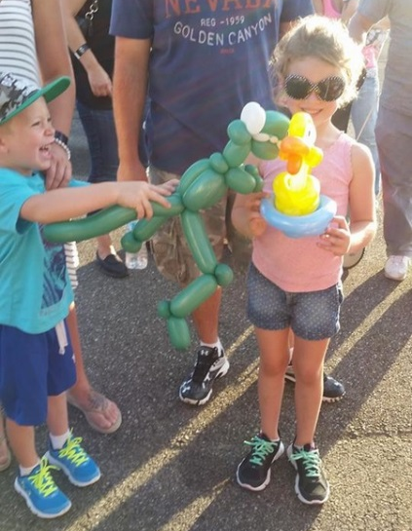

Description: J.D. is the area's best loved and most talented balloon artist with a repertoire of hundreds of designs, many of them his original creations! We serve a large area of Western Pennsylvania and Eastern Ohio. We travel about 100 miles from our home base, which is about half way between Pittsburgh, Pennsylvania and Erie, Pennsylvania.

We also offer DJ service, airbrush tattoos, glitter tattoos, and balloon decor (our newest addition)! In other words, we have everything you need to make your event truly special, and our prices are very affordable!

Rates: The 2-hour workshop price is $275 for up to 10 students and $15 per student after that.

Our entertainment rates for one hour are $85/one artist, &150/2 artists, $200/3 artists.
Three hour rates are $225/artist $400/2 artists $550/3 artists.

We currently can offer the following combination of services:
One service = Balloons, Airbrush Tattoos, facepaint
2 services = 2 Balloon artists, 1 Balloon artist & tattoos, 1 Balloon artist & facepaint, tattoos & facepaint
3 services = 2 Balloons & facepaint, 2 Balloons & tattoos, 1 Balloon & tattoos & facepaint.
Recommended by: Becky @ New Castle is hiring him for the first time in 2018
I believe Heather @ Grove City uses him regularly

Updated: 2/2018

